BLANK LINE
BLANK LINE

CLICK HERE, TYPE THE TITLE OF YOUR PAPER

(16 Points)
BLANK LINE
Name Surname Name Surname Name Surname
BLANK LINE
BLANK LINE

Abstract (12 Pt.)
BLANK LINE
Abstract should be written in Microsoft Word format with Calibri font 10 pt. size and single-spaced. The length of the abstract should be minimum 200 words and maximum 300 words. The abstracts should concisely present the purpose of the study, the methodology, the results, and the conclusion remarks. References are not cited within the structured abstracts and the abstracts must not contain abbreviations.
BLANK LINE
Keywords: 4-6 keywords that are important and relevant to your manuscript should be written under the abstract.
BLANK LINE
JEL Classification Codes: The manuscript should contain 2-3 classification codes.
BLANK LINE
BLANK LINE

1. Introduction (14 Pt.)
Introduction should be minimum 150 words and maximum 250 words. Introduction should clearly present the importance, the purpose, the methodology and the scope of the study.
BLANK LINE

2. Main Heading (14 Pt.)
Main text should be in Microsoft Calibri with 12 font size and single-spaced. The whole main text should be justified. Paragraph spacing after a single paragraph (6 nk) should be given. The first line of the paragraph is to be shifted by 1,25 cm from the left margin. Headings and sub-headings of the manuscript should be numbered as 1., 1.1., 1.1.1. in hierarchical numbers. The headings should be numbered beginning from the Introduction, without the exception of References. All heading should be written bold but only the first letters should be capital. Before a heading, blank line should be given.
The main text should be between 800-1.200 words. More than one heading and sub-heading can use in the study. These headings should include literature, methodology, results, discussions etc. Citations in the text should be made using the link method. In-text citations, the author’s last name, date of the publication, the number of the quoted pages should be mentioned.
Examples of citations in the text: Single Author (Torgler, 2007: 135).
Two Authors (Acemoglu & Robinson, 2005: 122).
BLANK LINE
2.1. Sub-heading (12 Pt.)
If the name of the referred author is given within the text, then only the publication date should be written. If there are two authors the surnames of both should be given. When there are 3-5 authors in the cited source, surnames of all authors should be listed in text for the first citations. Afterwards, only the surname of the first author followed by “et al.” should be written. When an author has published more than one cited document in the same year, these are distinguished by adding lower case letters “a, b, c etc.” after the year and within the parentheses. For multiple references, the citations should be ordered chronologically and separated them with semicolons (;).
Examples of citations: Three or more authors (Kirchler et. al., 2014: 90).
Two studies of same author (Due, 1971a: 58; Due, 1972b: 195).
BLANK LINE
2.2. Sub-headings (12 Pt.)
All Tables and figures should be consecutively numbered as Table 1, Figure 1. The titles of the tables and figures should be placed at the heading of the table or figures, and references belonging to table or figure should be under them. The figures and tables with their names should be centered in the text. All headings should be written bold but only the first letters should be capital. Text in the tables should be written in Microsoft Word format with Arial Narrow 10 or 11 pt. Figures and tables should be separated from the text by one-line interval.
BLANK LINE
Table 1. The title should be placed at the heading and centered of the table
Source: OECD, 2016: 83.
BLANK LINE

3. Main Heading (14 Pt.)
If necessary, more main headings can be used.
BLANK LINE
3.1. Sub-headings (12 Pt.)
First paragraph
Second paragraph
BLANK LINE

Figure 1. Effective Tax Rates on Gasoline vs. Diesel in Selected Countries
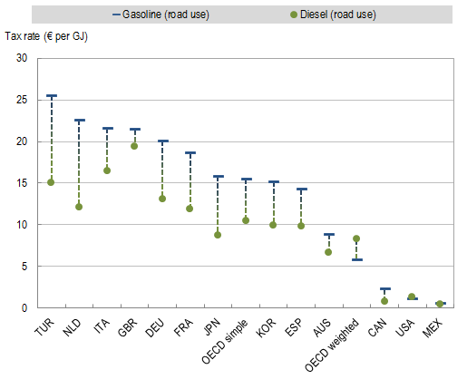
Source: OECD, 2013.
BLANK LINE
Third paragraph
If necessary, more main sub-headings can be used.
BLANK LINE

4. Conclusion (14 Pt.)
Conclusion should be minimum 150 words and maximum 250 words. Conclusion should clearly present the results of the study, evaluations and suggestions.
BLANK LINE
BLANK LINE

References (14 Pt.)
The list of references (minimum 10 and maximum 20 references) should be presented in alphabetical order at the end of the manuscript. Each citation in text should be listed in the references section, and references which are not cited in text should not be written in the references section. If the author referred to more than one publication from the same source, the oldest publication should be listed first. If the author referred to more than one publication from the same source published in the same year, the publications should be numbered using the letters a, b, c, … as citation in the text. If one author’s several publications, some with one some with two or more authors, are referred to, the publications with one author should be written first. Page numbers of articles published in the journals and chapters in the edited books should be written.

Examples of reference formats are shown below:
Journals/Periodicals;
Feldstein, M. (2002). “The Transformation of Public Economics Research: 1970–2000”, Journal of Public Economics, 86 (3), pp. 319-326.
Kirchler, E., Kogler, C. & Muehlbacher, S. (2014). “Cooperative Tax Compliance: From Deterrence to Deference”, Current Directions in Psychological Science, 23 (2), pp. 87-92.
Books;
Lang, M. (2013). Introduction to The Law of Double Taxation Conventions, Netherlands, IBFD.
Acemoglu, D. & Robinson J. (2013). Why Nations Fail: The Origins of Power, Prosperity and Poverty, New York, Crown Business.
Brunnermeier, M. K., James, H. & Landau, J. P. (2016). The Euro and The Battle of Ideas, New Jersey, Princeton University Press.
Due, John F. (1971a). Indirect Taxation in Developing Economics, Baltimore, The John Hopkins Press.
Due, John F. (1971b). Government Finance: Economies of the Public Sector, Illinois, Richar D. Irwin Inc.
Edited Books;
Baker, P. (2009). “Taxpayers’ Charter and a Taxpayers’ Charter for Europe”, Protection of Tax-payer’s Rights European, International and Domestic Tax Law Perspective”, (Ed.) Nykiel W. & Sek M., Wolters Kluwer Business, Warszawa, pp. 130-135.
Thesis;
Salanauskaite, L. (2012). “Distributional Impacts of Public Policies”, (PhD Thesis), Maastricht University, Maastricht.
Reports;
Committee For The Study of Economic and Monetary Union. (1989). Report on Economic and Monetary Union in the European Community, Madrid, http://aei.pitt.edu/, (02.10.2016).
European Commission. (2015). Taxation trends in the European Union, Data for the EU Member States, Iceland and Norway, ISSN: 2467-0073, Luxembourg.
Papers;
Quliyeva, A. A. (2015). “The New Paradox of Modern Asymetric Economy”, 1st International Annual Meeting of Sosyoekonomi Society, 29-30 October 2015, Munich, Germany.
Internet Sources;
International Monetary Fund. (2016). Corruption: Costs and Mitigating Strategies, https://www.imf.org/external/pubs/ft/sdn/2016/sdn1605.pdf, (01.11.2016).

Academic title, Institute/Company, e-mail (Corresponding author)
Academic title, Institute/Company, e-mail
Academic title, Institute/Company, e-mail

